**Xtreme Beginnings Career Event**

***Learning Through Work!***

On Tuesday, April 15, 2025, the Career Development Coordinators of the Wake County Public School System will host the annual **Xtreme Beginnings Career Event** held at the McKimmon Center located at 1101 Gorman Street, Raleigh, NC. The event will run from 9:00 AM to 12:00 noon.

We are seeking a variety of business and post-secondary education professionals to volunteer their career expertise to make this event a success. Volunteers are needed in the following areas:

**1.** **College & Career Pathways Room:** Students engage in informal discussions with career professionals and representatives from post-secondary institutions. Volunteers have the opportunity to showcase their organization with table top displays and handouts. The free flow format enables students to focus on their specific interests. Approximately 60 tables will be available.

Companies with current job opportunities and seeking to hire high school students will be able to speak directly with students. Opportunities may include full-time, part-time, seasonal/temporary, internships, etc.

**2.** **Practice Interview Room:** A mock or practice interview provides students with an opportunity to test out their interview skills with someone who isn’t evaluating them for an actual job. Students are interviewed for approximately 20 minutes from a professional who can provide them with feedback on whether or not their responses are suitable and also provide tips on their resume. Approximately 90 volunteers are needed in this area.

To register for this event, please complete the online registration form by going to <https://tinyurl.com/WCPSS2025XB>. Upon completion of your registration, your information will be automatically uploaded to the Xtreme Beginnings 2025 database & you will be contacted with specific information and instructions as we near the date of the event. If you are unable to participate but know someone who may be interested, please forward them this email. The registration **DEADLINE** is Tuesday, April 8, 2025.

Xtreme Beginnings is an important event that opens the eyes and minds of tomorrow's workforce to an array of educational and career opportunities. We invite you to view a short video which showcases Xtreme Beginnings:<https://www.youtube.com/watch?v=DdbKm85jjoU>

Thank you,

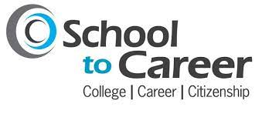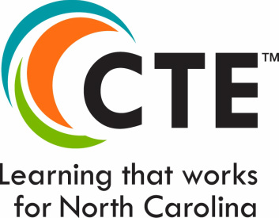 WCPSS High School Career Development Coordinators